The Ministry of Justice

25 September 2022

To whom it may concern
Coroners Amendment Bill - Submissions
- A purpose of the Coroners Act 2006 requires the coroner to investigate sudden deaths and make recommendations or comments that, if drawn to public attention, may reduce the chances of similar deaths.

- I oppose the Coroners Amendment Bill, which will allow the coroner to record the cause of death as "unascertained natural causes" if the coroner considers that:

- the death is from natural causes; and
- no further investigation is required.

- The coroner is not required to consider any set factors when making this decision or provide information regarding the circumstances of the death if the coroner considers there is no public interest in doing so.

- A coroner has legal, not medical, qualifications. A pathologist should be involved in the decision to understand the cause and circumstances of the death.

- Two of the stated purposes of the Bill are to enable families and whānau to receive a coroner's findings sooner and free up the coroners' time to work on reducing the number of active coronial cases. While I appreciate the importance of these two purposes, there is a real risk that the amendment will result in sudden deaths not being investigated.

- The proposed amendment does not serve the public interest given that:

- Sudden Adult Death Syndrome ("SADS") is being reported worldwide; and
- There is a sudden increase in all-cause mortality.

- Eurostate is the statistical office of the European Union. Eurostate reports that excess mortality climbed to +16% in July 2022 from +7% in June and May. The percentage represents around 53 000 additional deaths in July this year compared with the monthly averages for 2016-2019." Professor John Gibson recently reviewed excess deaths per week in New Zealand from April 2020 through July 2022. Professor Gibson found that there had been almost 3000 excess deaths in eight months, representing a 13% increase.

- As the increase in all-cause mortality can not be explained by Covid-19 deaths, the coroner needs to consider the impact of the vaccine. The vaccine is known to cause death and result in diseases which can lead to death.

- Before releasing the vaccine in New Zealand, the advisory group understood that significant delayed adverse consequences of vaccination could occur within two months of vaccine receipt. Following the rollout of the mass vaccination, the Coroner's Court advised the MOH that the timeframe could be as long as 93 days following vaccination.

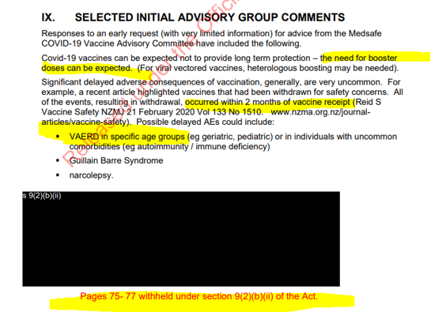

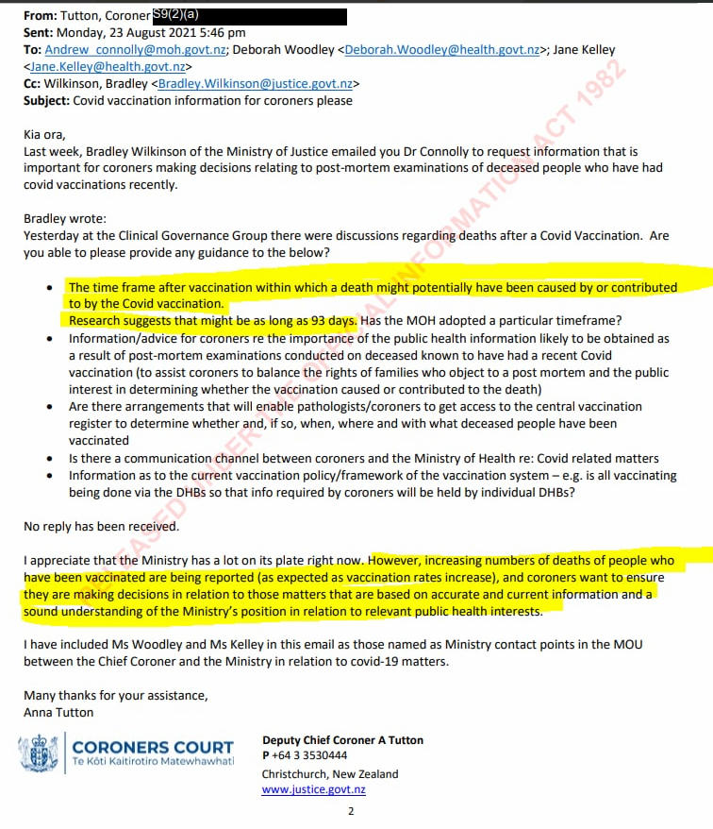

- Given that the Government and the Coroner's Court agree that death following the vaccination may occur up to 93 days after the administration of the vaccine, every SADS death should be investigated to preserve the integrity of the coronial system.

Yours sincerely

[Name]

https://ec.europa.eu/eurostat/web/products-eurostat-news/-/ddn-20220916-1
https://www.nzcpr.com/best-in-show/

